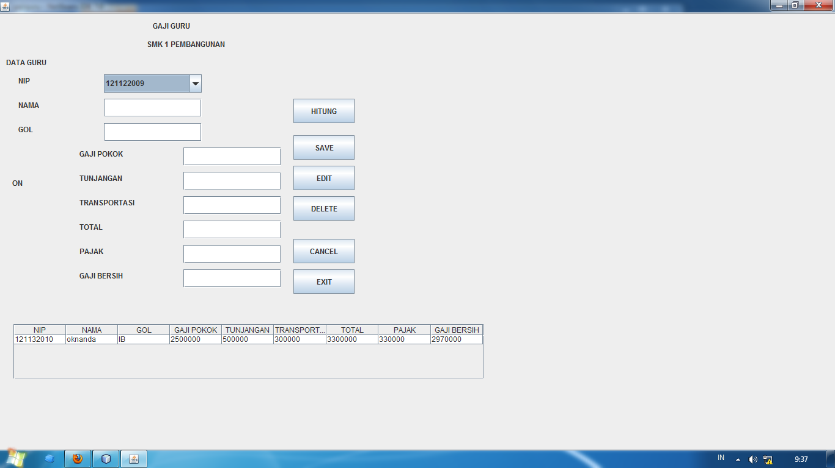

* @author Labor2

*/

**import java.sql.Connection;**

**import java.sql.DriverManager;**

**import java.sql.ResultSet;**

**import java.sql.Statement;**

**import java.text.SimpleDateFormat;**

**import javax.swing.JOptionPane;**

**import javax.swing.table.DefaultTableModel;**

public class gajiguru extends javax.swing.JFrame {

**private String q;**

**private Connection con;**

**private Statement st;**

**private ResultSet rs;**

/** Creates new form gajiguru */

public gajiguru() {

initComponents();

**koneksi();**

**insert_tabel();**

**setLocationRelativeTo(null);**

**this.setExtendedState(MAXIMIZED_BOTH);**

}

**private void koneksi(){**

**try {**

**Class.forName("sun.jdbc.odbc.JdbcOdbcConnection");**

**con=DriverManager.getConnection("jdbc:mysql://localhost/db_gajiguru","root","");**

**st=con.createStatement();**

**vstatus.setText("ON");**

**JOptionPane.showMessageDialog(null, "terkoneksi");**

**} catch (Exception e) {**

**vstatus.setText("OFF");**

**}**

**}**

**KODING EXIT**

**this.dispose();**

**KODING HITUNG**

**String gol="";**

**int gaji=0,tunj=0,trans=0,pajak=0,gajibersih=0,total=0;**

**gol=vgol.getText().toString();**

**if(gol.compareTo("IA")==0)**

**{**

**gaji=2000000;**

**tunj=1000000;**

**trans=450000;**

**}else if(gol.compareTo("IB")==0)**

**{**

**gaji=2500000;**

**tunj=500000;**

**trans=300000;**

**}else if(gol.compareTo("IC")==0)**

**{**

**gaji=3000000;**

**tunj=300000;**

**trans=200000;**

**}**

**vgaji.setText(String.valueOf(gaji));**

**vtunjangan.setText(String.valueOf(tunj));**

**vtransportasi.setText(String.valueOf(trans));**

**total=gaji+tunj+trans;**

**vtotal.setText(String.valueOf(total));**

**pajak=(int)(0.1*total);**

**vpajak.setText(String.valueOf(pajak));**

**gajibersih=total-pajak;**

**vgajibersih.setText(String.valueOf(gajibersih));**

**KODING CANCEL**

**vnama.setText("");**

**vgol.setText("");**

**vgaji.setText("");**

**vtunjangan.setText("");**

**vtransportasi.setText("");**

**vtotal.setText("");**

**vpajak.setText("");**

**vgajibersih.setText("");**

**KODING PADA COMBO NIP**

**int kode=0;**

**kode=vnip.getSelectedIndex();**

**kode++;**

**if (kode==1){**

**vnama.setText("emsa nurjannah");**

**vgol.setText("IA");**

**} else if (kode==2){**

**vnama.setText("oknanda");**

**vgol.setText("IB");**

**} else if (kode==3){**

**vnama.setText("defrianto");**

**vgol.setText("IC");**

**}**

**KODING SIMPAN**

**try {**

**q="insert into gaji_guru values (' "+vnip.getSelectedItem()+" ',' "+vnama.getText()+" ',' "+vgol.getText()+"','"+vgaji.getText()+"','"+vtunjangan.getText()+"','"+vtransportasi.getText()+"','"+vtotal .getText()+"','"+vpajak.getText()+"','"+vgajibersih.getText()+"')";**

**st.execute(q);**

**JOptionPane.showMessageDialog(null,"data telah disimpan");**

**insert_tabel();**

**} catch (Exception e) {**

**JOptionPane.showMessageDialog(null,e.getMessage());**

**}**

**KODING EDIT**

**try {**

**st.executeUpdate("update gaji_guru set nama='"+vnama.getText()+"',gol='"+vgol.getText()+"',gaji_pokok='"+vgaji.getText()+"',tunjangan='"+vtunjangan.getText()+"',transfortasi='"+vtransportasi.getText()+"',total='"+vtotal.getText()+"',pajak='"+vpajak.getText()+"',gaji_bersih='"+vgajibersih.getText()+"'where nip='"+vnip.getSelectedItem()+"'");**

**JOptionPane.showMessageDialog(rootPane,"Update berhasil.....");**

**insert_tabel();**

**} catch (Exception e) {**

**JOptionPane.showMessageDialog(rootPane,"Update gagal.......!!!"+e);**

**}**

**KODING HAPUS**

**try {**

**st.executeUpdate("delete from gaji_guru where nip='"+vnip.getSelectedItem()+"'");**

**JOptionPane.showMessageDialog(rootPane,"Delete berhasil.....SARI horeeee");**

**insert_tabel();**

**} catch (Exception e) {**

**JOptionPane.showMessageDialog(rootPane,"Delete gagal.......!!!"+e);**

**}**

**KODING TABEL**

**public void insert_tabel(){**

**DefaultTableModel tbl= new DefaultTableModel();**

**tbl.addColumn("NIP");**

**tbl.addColumn("NAMA");**

**tbl.addColumn("GOL");**

**tbl.addColumn("GAJI POKOK");**

**tbl.addColumn("TUNJANGAN");**

**tbl.addColumn("TRANSPORTASI");**

**tbl.addColumn("TOTAL");**

**tbl.addColumn("PAJAK");**

**tbl.addColumn("GAJI BERSIH");**

**try {**

**int nomor= 1 ;**

**q="select * from gaji_guru";**

**st=con.createStatement();**

**rs=st.executeQuery(q);**

**while (rs.next()){**

**tbl.addRow(new Object[]{**

**rs.getString("nip"),**

**rs.getString("nama"),**

**rs.getString("gol"),**

**rs.getString("gaji_pokok"),**

**rs.getString("tunjangan"),**

**rs.getString("transfortasi"),**

**rs.getString("total"),**

**rs.getString("pajak"),**

**rs.getString("gaji_bersih")});**

**}**

**tabel.setModel(tbl);**

**} catch (Exception e) {**

**JOptionPane.showMessageDialog(null, e);**

**}**

**}**

**KODING PEMANGGILAN PADA NIP**

**try {**

**q="select * from buku where kode_buku='"+vkode.getText()+"'";**

**st=con.createStatement();**

**rs=st.executeQuery(q);**

**if (rs.next()) {**

**vjudul.setText(rs.getString(2));**

**vjenis.setText(rs.getString(3));**

**}**

**} catch (Exception e) {**

**}**

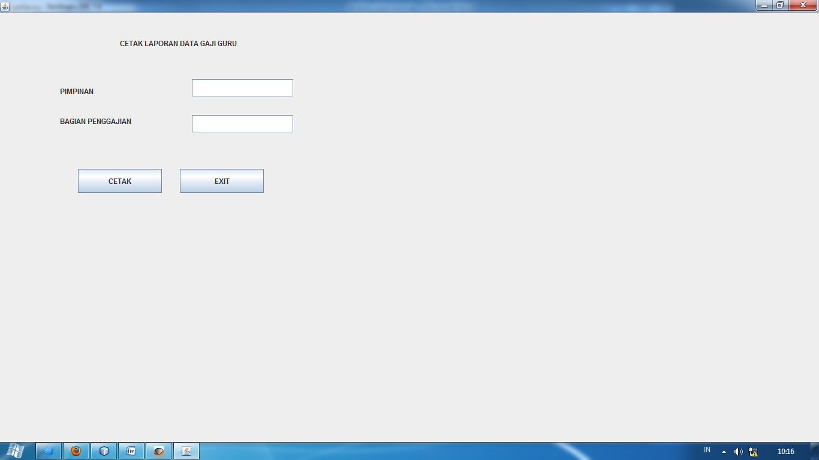

**import com.inet.viewer.SwingReportViewer;**

**import com.inet.viewer.URLRenderData;**

**import java.awt.BorderLayout;**

**import java.awt.Toolkit;**

**import javax.swing.JDialog;**

public class lap_gajiguru extends javax.swing.JFrame {

/** Creates new form lap_gajiguru */

public lap_gajiguru() {

initComponents();

**setLocationRelativeTo(null);**

**this.setExtendedState(MAXIMIZED_BOTH);**

}

KODING CETAK

**try {**

**JDialog window =new JDialog(this, "PRINT PREVIEW");**

**window.setSize(Toolkit.getDefaultToolkit().getScreenSize());**

**SwingReportViewer viewer=new SwingReportViewer();**

**URLRenderData renderData = new URLRenderData( "http://localhost:9000/?report=file:"+**

**System.getProperty("user.dir")+"/src/laporan/lap_gajiguru.rpt&prompt0="+vpimpinan.getText()+ "&prompt1="+vbagian_gaji.getText());**

**viewer.addNewReportView(renderData);**

**window.getContentPane().add(BorderLayout.CENTER,viewer);**

**window.setVisible(true);**

**} catch (Exception e) {**

**e.printStackTrace();**

**}**